PRACTICAL - 03
Aim:
To write a Python program to implement the Heap Sort algorithm using a Max-Heap.
Theory:
Heap Sort is a comparison-based sorting technique based on the Binary Heap data structure. A Max-Heap is a complete binary tree in which the value of each parent node is greater than or equal to the values of its children — meaning the largest element is always at the root.
Heap Sort works in two main phases:
- Build Max-Heap: Convert the given array into a max-heap, so the largest element is at the root (index 0).
- Extract elements: Repeatedly swap the root (maximum element) with the last element of the heap, reduce the heap size by one, and heapify the root again to restore the max-heap property. This places the largest remaining element at the correct sorted position at the end of the array each time.
This process continues until the entire array is sorted in ascending order. Heap Sort has a time complexity of O(n log n) in all cases (best, average, and worst), and it sorts in place, requiring O(1) extra space, unlike Merge Sort.
Algorithm:
- Input the array of elements.
- Build a max-heap from the input array:
  - Starting from the last non-leaf node down to the root, call heapify() on each node.
- heapify(arr, n, i): compare node i with its left child (2i+1) and right child (2i+2); find the largest among the three; if the largest is not the root, swap and recursively heapify the affected subtree.
- Once the max-heap is built, repeat until the heap size is 1:
  - Swap the root element (maximum) with the last element of the heap.
  - Reduce the heap size by one.
  - Call heapify() on the root to restore the max-heap property.
- Display the sorted array.

Program Code:
def heapify(arr, n, i):
largest = i
left = 2 * i + 1
right = 2 * i + 2

if left < n and arr[left] > arr[largest]:
largest = left

if right < n and arr[right] > arr[largest]:
largest = right

if largest != i:
arr[i], arr[largest] = arr[largest], arr[i]
heapify(arr, n, largest) # recursively heapify the affected subtree

def heap_sort(arr):
n = len(arr)

# Step 1: Build a max heap (start from last non-leaf node, go up to root)
for i in range(n // 2 - 1, -1, -1):
heapify(arr, n, i)

# Step 2: Extract elements one by one from the heap
for i in range(n - 1, 0, -1):
arr[0], arr[i] = arr[i], arr[0] # move current max to the end
heapify(arr, i, 0) # heapify reduced heap
return arr

# Demo
if __name__ == "__main__":
data = [74, 33, 12, 20, 10, 3, 37, 90]
print("Original array: ", data)
print("Heap Sorted: ", heap_sort(data.copy()))

Output:
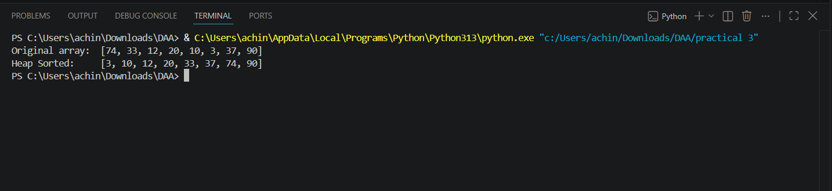

Result:
The program successfully implements the Heap Sort algorithm using a Max-Heap. The array is first converted into a max-heap, and then elements are repeatedly extracted from the root and placed in sorted order. Heap Sort achieves a time complexity of O(n log n) and sorts the array in place without requiring additional memory.

